Lathe tool bit

A tool bit is a non-rotary cutting tool used in metal lathes, shapers, and planers. Such cutters are also often referred to by the set-phase name of single-point cutting tool, as distinguished from other cutting tools such as a saw or water jet cutter, the cutting edge is ground to suit a particular machining operation and may be resharpened or reshaped as needed. The ground tool bit is held rigidly by a tool holder while it is cutting.

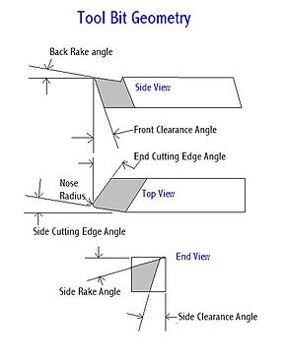

Kinds of Lathe tool bit

<http://littlemachineshop.com/products/product_focus.php?Focus=Cutting%20Tools%20Lathe>

Chamfering tool, ½” Indexable, SCSCR-08-3A, Tormach

* 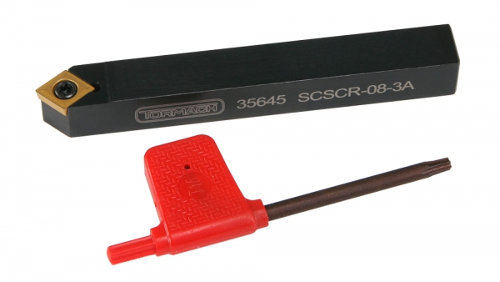 Designation: SCSCR-08-3A
* Steel shank ½” x 4”
* Designed for CCMT and CCGT 32.51 inserts
* Approach 45® , 7® relief angle
* Insert Shape: 80® (C)
* Price, $39.83

Grooving & Cut-off Tool, ½” indexable HHS Inserts, A R Warner

* 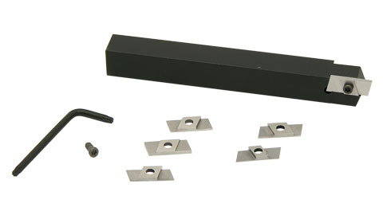For external grooving and cut-off operations
* Includes two 1/16” (.062”) groover T-15 high speed steel inserts
* Includes two 1/32” (.031”) groover T-15 high speed steel inserts
* Includes two 1/64” (.016”) groover T-15 high speed steel inserts
* Includes two IS 3007 screws and one T-9 wrench
* Price, $135.00